# Software Project Management Plan

**Team members：**

**刘哲峰**

**曾科特**

**李鹏飞**

**刘通**

Contents

Software Project Management Plan 1

1. Introduction 3

1.1 Project overview 3

1.2 Project deliveribles 3

1.3 Evolution of this document 4

1.4 References 4

1.5 Definitions, acronyms, and abbreviation 5

2. Project organization 5

2.1 Process model 5

2.2 Organization structure 5

2.3 Organizational boundaries and interfaces 6

2.4 Project responsibilities 6

3. Goals & Scope 7

3.1 Goals 7

3.2 Non-Goals 8

4. Managerial process 8

4.1 Management objectives and priorities 8

4.2 Assumptions, dependencies and contraint 8

4.3 Risk management 9

4.4 Monitoring and controlling mechanisms 9

5. Technical process 9

5.1 Methods, tools, and techniques 9

5.2 Software documentation 9

5.3 Project support functions 10

6. Work elements, schedule 10

## 1. Introduction

In the SHMUBlog Project a system has to be designed to support Internet communicating system. The system to be made consists of at least four main functions, which must interact the internet. The system may involve the basic activities, such as user sign in, article publishing, knowledge sharing and social communicating activities. The entire system has to be developed(in Python) in a way that it is easy to maintain and extend.

### 1.1 Project overview

Blog is usually called Web Log, as a popular way of communication on the Internet, it mainly provides a platform for users to simple, fast and convenient to publish their own experience, timely and easily communicate with others. Blog is after Email, BBS, ICQ after the emergence of the fourth kind of network communication, has been very popular with everyone, is the network era of personal "reader's digest", is a hyperlink as the entrance of the network diary, is a new way of life and new way of work, but also represents a new way of learning. communicate. Users can register in this system to apply for their own blog. Once users have applied for their own blogs, they can post their feelings and experiences on their blogs. When they post their articles, visitors can comment on the content of the logs published by users. Users can publish articles, pictures and messages on the blog to communicate with others. At present, the domestic excellent Chinese blog network: CSDN, JianShu, LOFTER and so on.

### 1.2 Project deliveribles

|  |  |
| --- | --- |
| **Devlivery Name** | **Date** |
| Project Plan/ Design | 12.03.2019 |
| Detail design | 19.03.2019 |
| Test plan | 16.04.2019 |
| Release for product | 07.05.2019 |
| All doc | 14.05.2019 |

### 1.3 Evolution of this document

This document will be updated as the project progresses. Updates should be expected in the following sections:

1. ***References*** - updated as necessary
2. ***Definitions, acronyms, and abbreviations*** - updated as necessary
3. ***Organizational Structure*** will be updated as the team leaders are assigned for each phase.
4. ***Technical Process*** - this section will be revised appropriately as the requirements and design decisions become clearer
5. ***Schedule*** - as the project progresses, the schedule will be updated accordingly

**Revision History**

|  |  |  |  |
| --- | --- | --- | --- |
| **Revision** | **Date** | **Updated By** | **Update Comments** |
| 0.1 | 09.03.2019 | 曾科特、刘通、李鹏飞、刘哲峰 | First Draft |
| 0.2 | 10.03.2019 | 曾科特、刘通、李鹏飞、刘哲峰 |  |

### 1.4 References

Code repository: <https://github.com/hellckt/SHMUBlog>

Project management software: <https://shmu.worktile.com/mission/work-timeline/5c7655db856a011d2956f6ab>

### 1.5 Definitions, acronyms, and abbreviation

1. AT - Acceptance Test
2. URD - User Requirements Definition
3. AD - Architectural Design
4. IT - Integration Test
5. ADD - Architectural Designed Document
6. DD - Detailed Design
7. DDD - Detailed Design Document
8. UT - Unit Tests

## 2. Project organization

### 2.1 Process model

The process used for this project will be a V-model such that each stage of the model allows us to do testing after completing a phases. Referring to the diagram below, each phase is tested after completion.

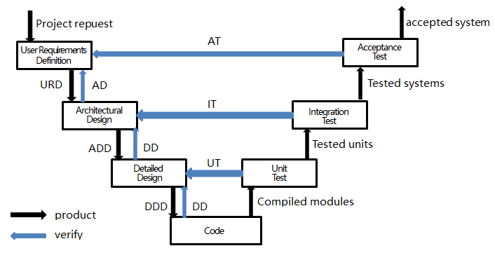

### 2.2 Organization structure

Team Members:

1. 刘哲峰
2. 曾科特
3. 刘通
4. 李鹏飞

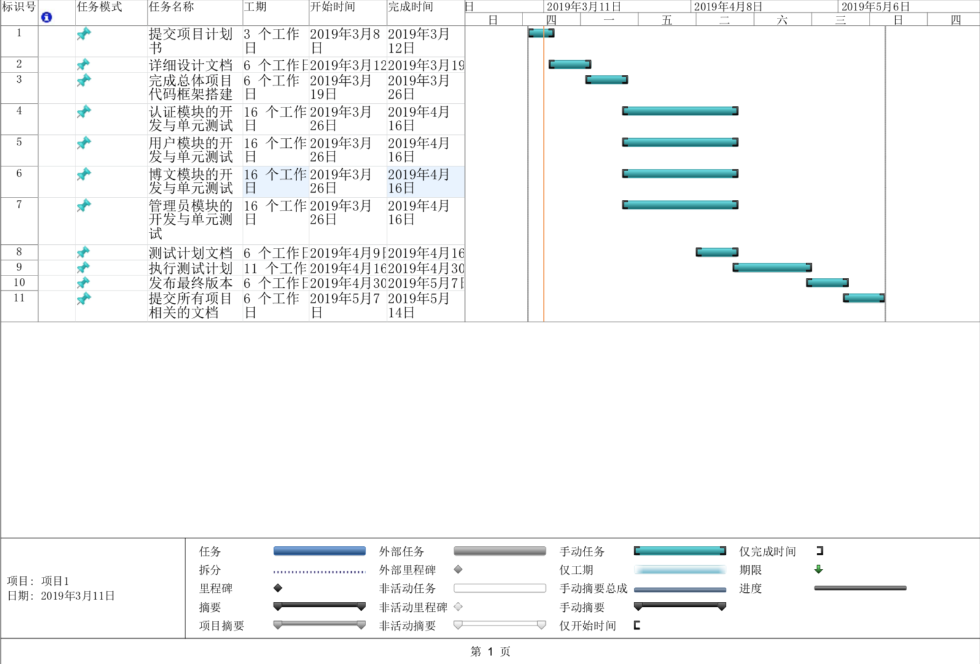

### 2.3 Organizational boundaries and interfaces

Team leaders throughout each development of the phases will be responsible for coordinating team meetings, updates, communications, and team deliverables.

### 2.4 Project responsibilities

For the most vital responsiblities per phase of each team members, please refer to segment 2.2. Ultimately the whole complete development of project team is responsible for the successful delivery of the product. The team member tasks per deliverable according to expertise and the phases below:

1. Project Plan - Entire Team
2. Plan Presentation(PPT) - 刘通
3. Detail design - Entire Team
4. Source Code - 曾科特、刘通、李鹏飞
5. Test Plan - 刘哲峰
6. Release for Product - 曾科特
7. Final Deliverable - Entire Team

## 3. Goals & Scope

Goals provide the primary objectives for the project and help define the scope. The following two sections specify this project’s prioritized goals and a series non­goals with explanations, in order to clarify scope, intentions, and direction of the project.

### 3.1 Goals

|  |  |  |
| --- | --- | --- |
| # | Goal | Priority |
| 1 | Ensure account security | P1 |
| 1.1 | User registration and login | P1 |
| 1.2 | Email address verification | P2 |
| 1.3 | Change and retrieve passwords | P2 |
| 2 | User modules | P1 |
| 2.1 | User role management | P1 |
| 2.2 | Personal information management | P1 |
| 2.3 | Focus on function | P1 |
| 3 | Blog Module | P1 |
| 3.1 | publish and manage article | P2 |
| 3.2 | manage comments | P2 |
| 4 | Administrator Module | P1 |
| 4.1 | review comments and articles | P2 |
| 4.2 | manage user | P2 |

### 3.2 Non-Goals

Defining non­goals clarifies the scope of the project by specifying attributes or functionality that are not in the scope of the project. The following table defines these non­goals and provides explanation as to why they are excluded for the project.

|  |  |  |
| --- | --- | --- |
| # | Non-Goal | Reasoning |
| 1 | Multi-browser support | Technical barriers and pressed for time |
| 2 | Mass user usage | This project is not market-oriented |
| 3 | Front end page beautification | There are no art designers |

## 4. Managerial process

### 4.1 Management objectives and priorities

The management objective is to deliver the product in time and of high quality. The PM and QA work together to achieve this by respectively checking that process is made as planned and monitoring the quality of the product at various stages.

### 4.2 Assumptions, dependencies and contraint

In this project plan, a number of factors are taken into account. For these refer the following list shows the way milestones on various project phases that have scheduled:

1. The team budget of 4 peoples x 80 hours = 320 hours
2. The project deadline of May 14th

### 4.3 Risk management

This section mentions any potential risks for the project. Also, schedules or methods are defined to prevent or to reduce the risks as below:

1. Technology risk
2. People risk
3. Structure/process risk

### 4.4 Monitoring and controlling mechanisms

The monitoring of progress is done by the PM using the following means:

1. Weekly project status meetings
2. Shared document respository
3. Project tracking by MS project plan
4. Tracking utilizing baselines in MS project

## 5. Technical process

### 5.1 Methods, tools, and techniques

The project will be implemented utilizing V-model methodology and tools such as Flask, Bootstrap, CKeditor, MariaDB, Sqlite3, PyCharm, Git, Worktile and Tencent Online Doc will be utilized. The risk for each category are listed to complete the project successfully. For each risk, a description, a probability to occur, the action associated and the impact of the risk are given.

### 5.2 Software documentation

Documentation such as project charter, Project Plan/ Design, Detail design, Test plan.

### 5.3 Project support functions

All project support documents will be completed in applicable phases.

## 6. Work elements, schedule

1. The project is accounted for project resources, technologies and tools required to whole analysis, implementation, and test of the application.
2. The project lead will be rotated for each phase within 4 team members.
3. The document for all phases will be revised in subsequent phases if applicable.